**WorkSheet:- 2.4**

**Student Name:** Vivek Kumar **UID:** 21BCS8129

**Branch:** BE-CSE (LEET) **Section/Group:** 20BCS-809/A

**Semester:** 4th Sem **Date of Performance:** 19/04/2022

**Subject Name:** SE Lab **Subject Code:** 20CSP-255

**AIM: -** Design a class diagram for the following scenario Library domain model

**Purpose:** Describe domain area for an Integrated Library System (ILS), also known as a Library Management System (LMS) - Library, CatLog, Book, Patron, Account.

**Summary:** Library Domain Model describes main classes and relationships which could be used during analysis phase to better understand domain area for ILS or LMS.

**Solution: -** Class diagram is a static diagram. It represents the static view of an application. Class diagram is not only used for visualizing, describing, and documenting different aspects of a system but also for constructing executable code of the software application.

**Purpose:**  The purpose of class diagram is to model the static view of an application. Class diagrams are the only diagrams which can be directly mapped with object-oriented languages and thus widely used at the time of construction.

The purpose of the class diagram can be summarized as –

* Analysis and design of the static view of an application.
* Describe responsibilities of a system.
* Base for component and deployment diagrams.
* Forward and reverse engineering.

**Library Domain Model:**

Library Domain Model describes main classes and relationships which could be used during analysis phase to better understand domain area for Integrated Library System (ILS), also known as a Library Management System (LMS). Each physical library item - book, tape cassette, CD, DVD, etc. could have its own item number. To support it, the items may be barcoded.

The purpose of barcoding is to provide a unique and scannable identifier that links the barcoded physical item to the electronic record in the catalog. Barcode must be physically attached to the item, and barcode number is entered into the corresponding field in the electronic item record. Barcodes on library items could be replaced by RFID tags.

The RFID tag can contain item's identifier, title, material type, etc. It is read by an RFID reader, without the need to open a book cover or CD/DVD case to scan it with barcode reader. Library book attributes ISBN and subject are inherited from Book and shown with prepended caret '^' symbol. The title attribute explicitly redefines name. While type of the attributes is the same, name is different. The lang attribute is explicitly redefined with different type. Original type was free text String, while redefined attribute is more specific (e.g., enumerated) Language class.

We used explicit redefinition in this case because attribute types String and Language are not related. Language is enumeration type. Library has some rules on what could be borrowed and what is for reference only. Rules are also defined on how many books could be borrowed by patrons and how many could be reserved. Library book attributes loan Period, due Date, and is Overdue are derived. Length of time a library book may be borrowed (loan period) depends on library policy and varies based on a kind of book and who is borrowing it.

For example, in a university library undergraduates could borrow book for 30 days, graduate students for a quarter, and faculty staff for a year. In a public library normal loan period for a book could be 3 weeks, while it could be lowered to 2 weeks for new books. Book return due date will be calculated based on the borrow date and loan period.

If due date is past the current date, is Overdue Boolean flag which is false by default will be set to true. Library Catalog provides access for the library patrons and staff to all sources of information about library items, allows to search by a particular author, on a particular topic, or in a particular format, that the library has. It tells the user where materials meeting their specific needs can be found.

Each physical library item - book, tape cassette, CD, DVD, etc. could have its own item number. To support it, the items may be barcoded. The purpose of barcoding is to provide a unique and scannable identifier that links the barcoded physical item to the electronic record in the catalog. Barcode must be physically attached to the item, and barcode number is entered into the corresponding field in the electronic item record.

Barcodes on library items could be replaced by RFID tags. The RFID tag can contain item's identifier, title, material type, etc. It is read by an RFID reader, without the need to open a book cover or CD/DVD case to scan it with barcode reader.

Library book attributes ISBN and subject are inherited from Book and shown with prepended caret '^' symbol.

The title attribute explicitly redefines name. While type of the attributes is the same, name is different. The lang attribute is explicitly redefined with different type. Original type was free text String, while redefined attribute is more specific (e.g., enumerated) Language class. We used explicit redefinition in this case because attribute types String and Language are not related. Language is enumeration type.

**Class Diagram:**

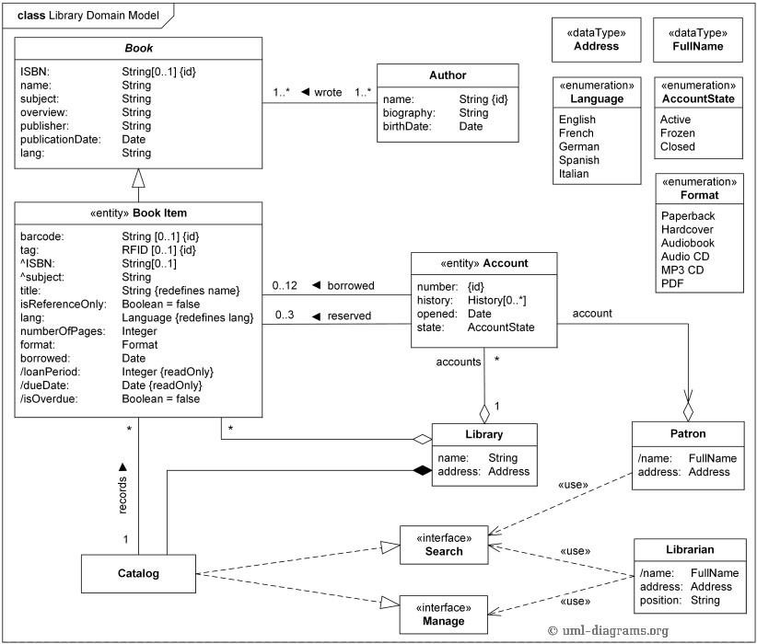

**Evaluation Grid (To be created as per the SOP and Assessment guidelines by the faculty):**

|  |  |  |  |
| --- | --- | --- | --- |
| Sr. No. | Parameters | Marks Obtained | Maximum Marks |
| 1. |  |  |  |
| 2. |  |  |  |
| 3. |  |  |  |
|  |  |  |  |